Resumé

Joachim Stougaard, Nikolaj Larsen, Ronny Christensen & Silas Meling

Svømmeklubben Delfinen

Dat17v1

Delfin projekt

Indhold

Use cases: 1

Use case diagram: 4

Domain Model: 4

SD Diagram: 5

Class diagram: 6

# Use cases:

Vi har valgt at lave fire use cases: “Create new member”, “Overview of top 5 members”, “Arrears” og “Update member”. Vi valgte dem fordi vi syntes det var dem der var mest spændende at lave et program ad, ud fra den givne opgave.

**Title:** Create new member

**Actor:** Admin

**Scenario:** The admin logs into the system and chooses “create new member”. He then enters name, age, swim discipline, membership status, level and balance.

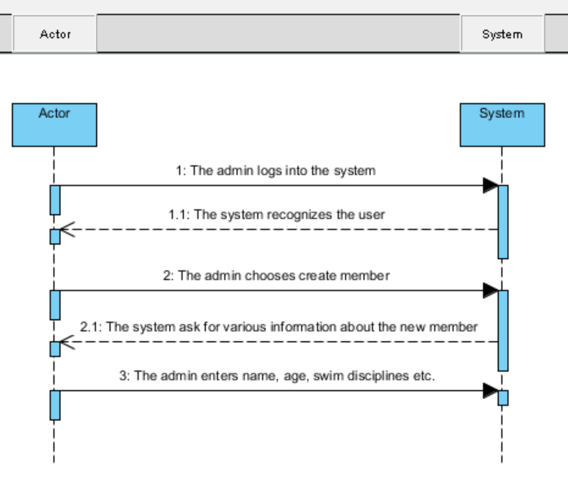

**Title:** Overview of top 5 members

**Actor:** Coach

**Scenario:** The coach logs on to the system and then chooses the “ Top 5” option. Then the System prints out list of top 5 Elite swimmers in all disciplines

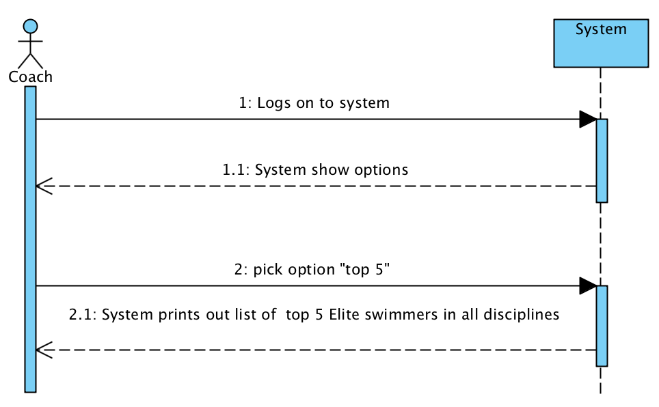

**Title:** Arrears

**Actor:** Management

**Scenario:** The admin can log into system and accesses list of members in arrears and can print out list of names and balance.

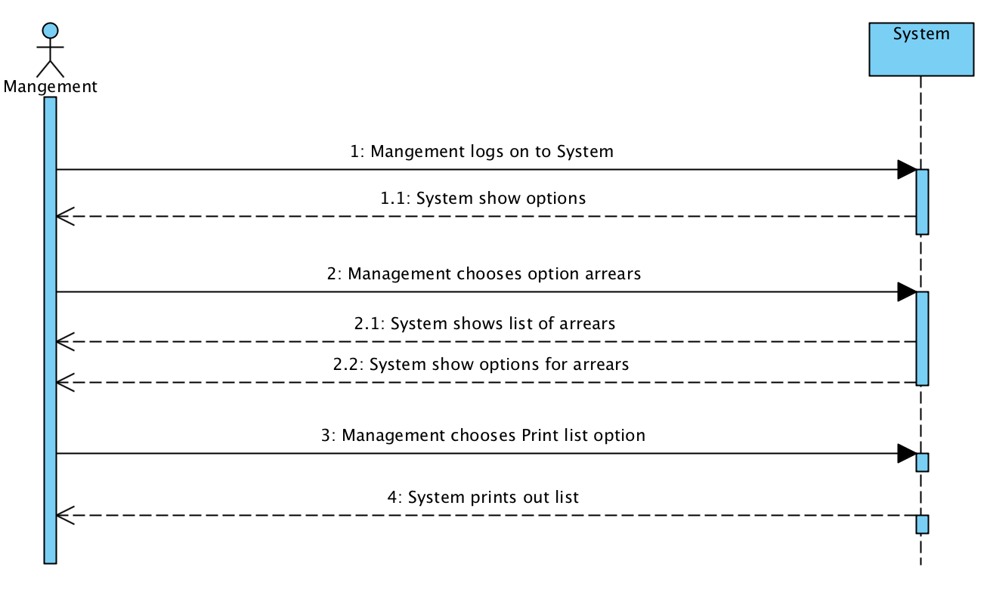

**Title**: Update member

**Actor:** Admin

**Scenario:**

Admin logs into the system and he chooses “update Admin”. the admin can now search for keywords and it will now print the members containing the keyword in their information. The admin can now choose what he wants to update. The system will print out the updated information.[1]

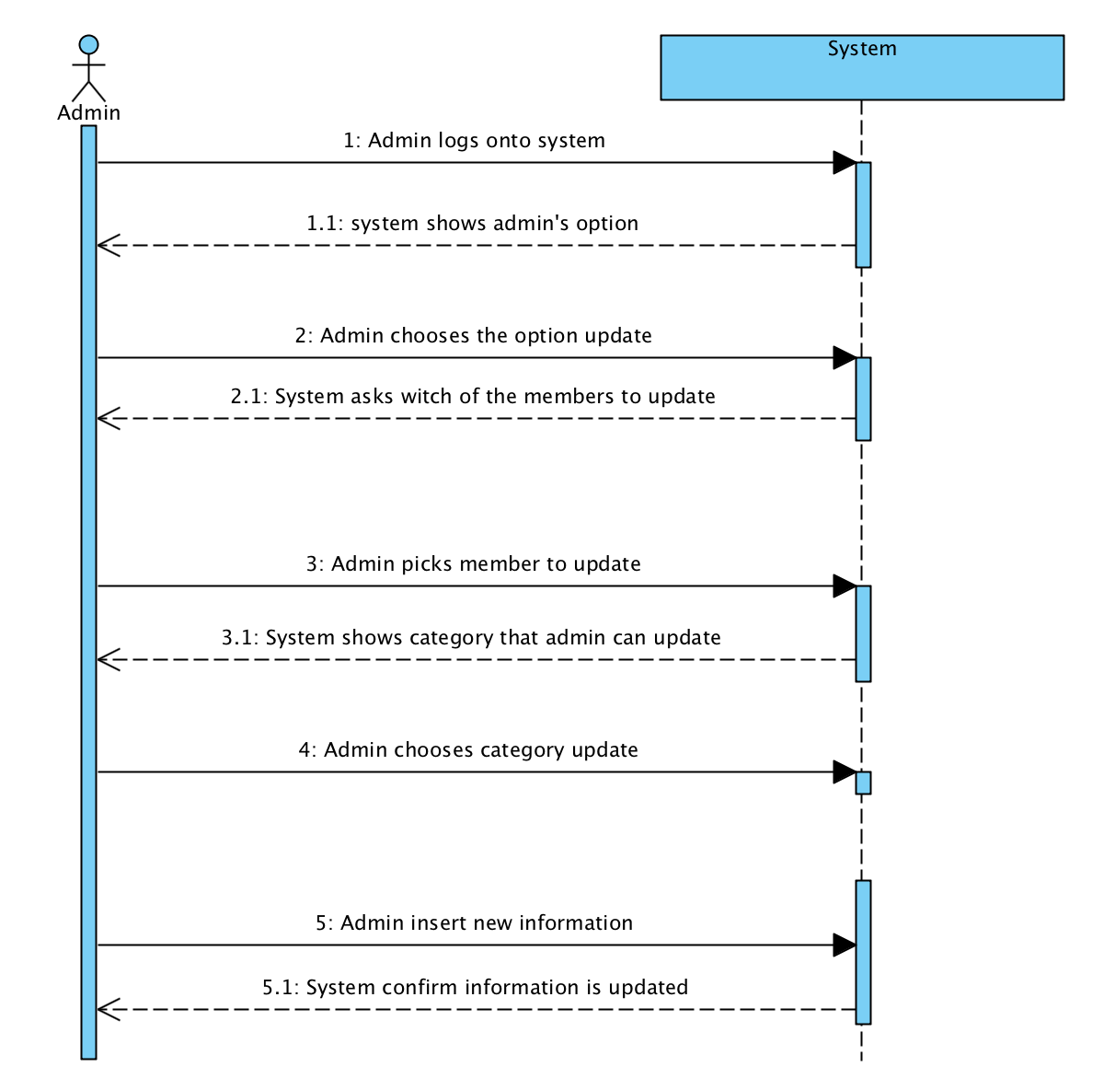

Vi har samlet alle de navneord og tillægsord vi har brugt i vores use cases og samlet den i nedenstående liste.

**Noun list:** Management, member, coach, admin.

**Verb list:** Chooses, register, enters, view, accesses, print, update

# Use case diagram:

Ud fra vores fire use cases har vi lavet et use case diagram.

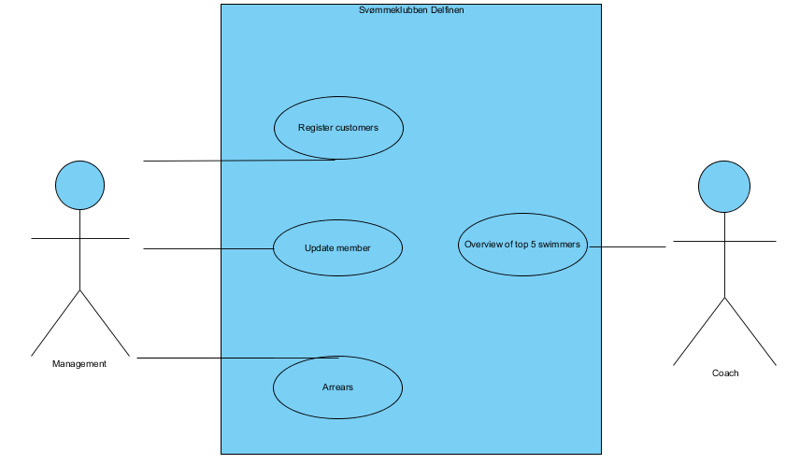

# Domain Model:

# 

Vi har lavet vores Domain Model ud fra vores noun list og verb list.

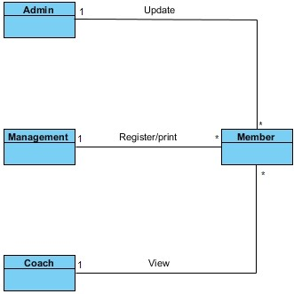

# SD Diagram:

Vi har valgt at lave et SD over metoden “updateAdmin()”, som kan gå ind og ændre oplysninger i arraylisten fra klassen Member.

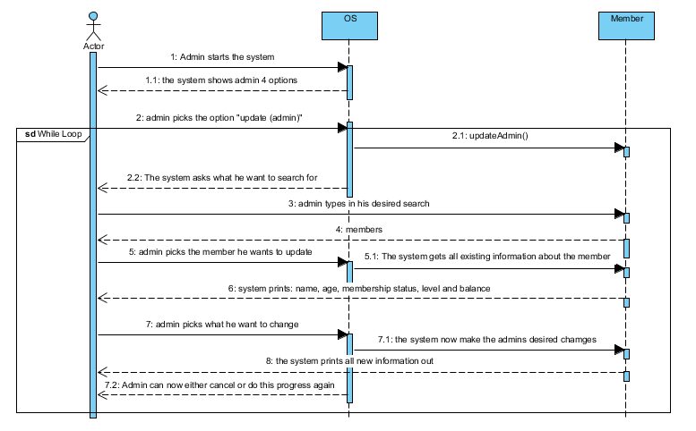

# Class diagram:

Vi har lavet vores klasse diagram ud fra vores første tanker om hvordan programmet skulle opbygges. Løbende opdaterede vi klassediagrammet så det gav mening i forhold til vores kode.

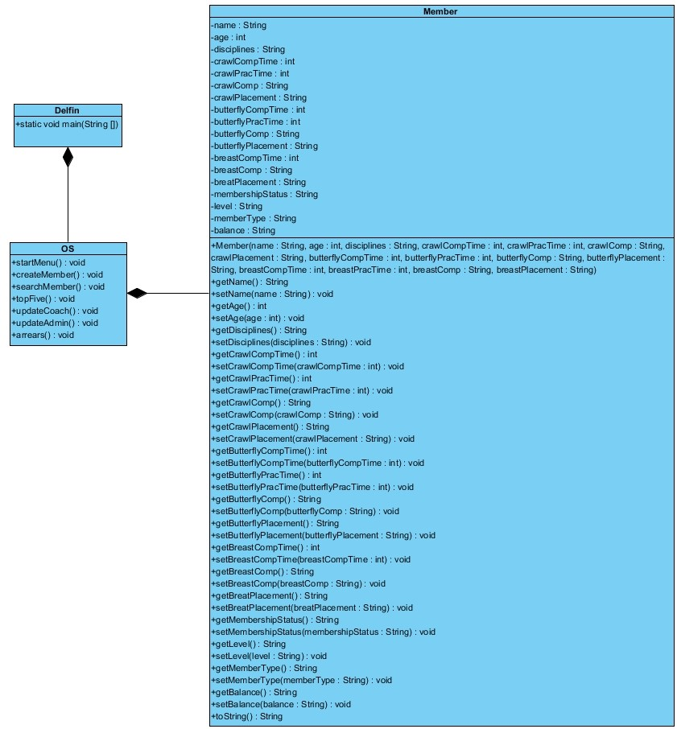

1. Samme princip gælder for ”update (Coach)”